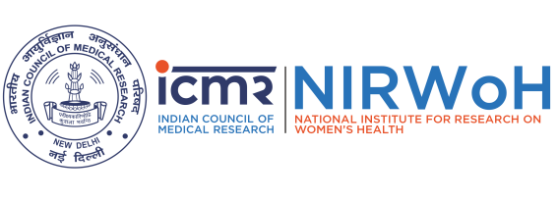
Protocol Violation/Deviation Reporting Form
(Reporting by case)
ICMR-NIRWoH Ethics Committee for Human Studies

Project No. …………………………………………………………………………………………………..
Title of study: …………………………………………………………………………………………………
……………………………………………………………………………………………………………….
Principal Investigator (Name, Designation, and Affiliation): ……………………………………………… Co-PIs/Collaborators (Name, Designation, and Affiliation): ………………………………………………………………………………………………………………….
……………………………………………………………………………………………………………………

- Date of EC approval: ………………………… Date of start of study: ………………………………….
- Participant ID: ………………………………... Date of occurrence: ……………………………………
- Total number of deviations /violations reported to date in the study: ………………………....................
- Deviation/Violation identified by: Principal Investigator/study team □ Sponsor/Monitor □
SAE Sub Committee/EC □
- Is the deviation related to (Tick the appropriate box) :
Consenting □  Source documentation □
Enrollment □ Staff □
Laboratory assessment □ Participant non-compliance □
Investigational Product □ Others (specify)  □
Safety Reporting □
- Provide details of Deviation/Violation: …………………………………………………………………………………......................
…………………………………………………………………………………………………………………

- Corrective action taken by PI/Co-PI: ……………………………………………………………………………………………….......................................................................................................................................................................
- Impact on (if any): Study participant □ Quality of data □
- Are any changes to the study/protocol required? Yes □ No□
If yes, give details…………………………………………….....................................……………………
……………………………………………………………………………………………………………………………………………………………….

Signature of PI with date: …………………………………………………………………………………………………………………………………

