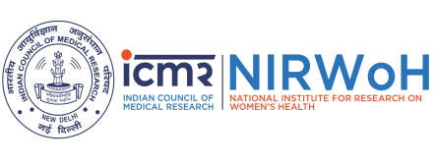
Format for Curriculum Vitae for Investigators
ICMR-NIRWoH Ethics Committee for Human Studies

Name:
Present affiliation (Job title, department, and Organisation):
Address (Full work address):
Contact Number:
Email address:
Qualifications:
Professional registration (Name of body, registration number and date of registration):
Previous and other affiliations (Include previous affiliations in the last 5 years and other current
affiliations):

Projects undertaken in the last 5 years:
Relevant research training/experience in the area¹
Relevant publications (Give references to all publications in the last five years plus other publications
relevant to the current application):

Signature with date:

Details of any relevant training in the design or conduct of research, for example in the Ethics Training, Human participants’ protection courses, Clinical Trials Regulations, Good Clinical Practice, consent, research ethics training or other training appropriate to non-clinical research. Give the date of the training

