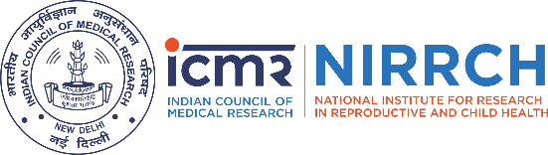

ICMR-National Institute for Research in Reproductive and Child Health
Organizes
National Science Day (NSD)-2026

11th March 2026 (Wednesday) 9:30 AM-01:00 PM
Venue: Dr. Shanta Rao Auditorium, ICMR-NIRRCH, Mumbai.
Program Schedule

Time | Program
9:30 – 10:00 AM | Breakfast
10:00 – 10:15 AM | Welcome Address by the Director, ICMR-NIRRCH
10:15 – 11:00 AM | Invited Talk by Mr. Nachiket Joshi, Behavioral Consultant & Experiential Learning Specialist, Auctus  Topic: “Emotional Intelligence in Scientific Work: From Concept to Daily Practice”
11:00 – 11:45 AM | Invited Talk by Padma Shri Dr. Armida Fernandez, MD (Pediatrics), DCH, FIAP, FNNF.  Former Dean & Head, Department of Neonatology, LTMG (Sion) Hospital, Mumbai  Topic: “Innovations in a Medical Setting – My Journey”
11:45 AM – 12:15 PM | Quiz Competition for Administrative Staff
12:15 – 12:45 PM | Debate: “Open Access Research: Right or Risk?”
12:45 – 12:55 PM | Prize Distribution
12:55 – 1:00 PM | Vote of Thanks

Participants must share their names in advance by sending an email to the National Science Day Committee: ittak@nirrch.res.in or kumarin@nirrch.res.in - Last date for registration is 9th March 2026 till 5:00 pm. No further extension will be given.

Debate topic: “Open Access Research: Right or Risk?”

Rules for Debate Competition

- The debate will follow a “For” and “Against” format.
- Each participant will be allotted 3 minutes to present their arguments.
- A warning bell will be given at 2 minutes 30 seconds.
- Exceeding the allotted time may result in a deduction of marks.
- Participants may speak in English or Hindi.
- Use of verified data and relevant examples is encouraged.
- The decision of the judges will be final and binding.

Reel competition topic: “Unsung Indian Scientific Heroes”.
Rules for reel competition:
- The reels should be of ≤60 seconds duration.
- Longer duration reels will be disqualified.
- Plagiarism is strictly prohibited.
- Use of verified data and relevant examples is encouraged.
- The decision of the judges will be final and binding.
- Participants may use English or Hindi.

