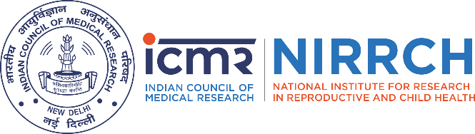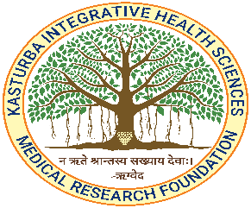
XXXIV PROF. P. K. DEVI MEMORIAL ORATION
by
Prof. (Dr.) T. Sundararaman
Former Director, National Health Systems Resource Center, New Delhi
Former Professor and Dean, School of Health Systems Studies,
Tata Institute of Social Sciences, Mumbai

On

“Women's Rights and Reproductive Technologies - A Complex Interface”

In the presence of
Chief Guest
Smt. Sujata Saunik
Former Chief Secretary, Government of Maharashtra

Guest of Honor
Dr. Soumik Kalita
Chief Executive Officer and Founder, “Family Health Physician: The Physician on Call”

Jointly Organized
by

ICMR-National Institute for Research in Reproductive and Child Health, Mumbai

and

Kasturba Integrative Health Sciences - Medical Research Foundation, Mumbai

Date: 9th October, 2025 Time: 11 am - 1 pm

Venue: Dr. Shanta Rao Auditorium, ICMR NIRRCH
Jehangir Merwanji Street, Parel, Mumbai

We cordially invite you to attend the function

Dr. Geetanjali Sachdeva  Director  ICMR -NIRRCH  Mumbai | Dr. Rama Vaidya  Chairman  KIHS - MRF  Mumbai | Dr. Shobha Udipi  CEO  KIHS – MRF  Mumbai | Dr. Smita Mahale  Ex-Director  ICMR -NIRRCH  Mumbai
Dr. Beena Joshi  Scientist G  ICMR -NIRRCH  Mumbai | Dr. Jayashree Joshi  Professor Emeritus  KIHS –MRF Mumbai | Dr. Anushree Patil  Scientist F  ICMR -NIRRCH  Mumbai | Ms. Shubhada Aghashe  Asst Director  KIHS -MRF  Mumbai
Program
11. 00 | Invocation and Lamp lighting
11. 10 | Welcome Address | Dr. Geetanjali Sachdeva (ICMR NIRRCH)
11. 15 | Prof. P. K. Devi: A Legend | Dr. Jayashree Joshi (KIHS-MRF)
11. 25 | Introduction of Chief Guest | Dr. Ashwinkumar Raut (KIHS-MRF)
11. 30 | Address by Chief Guest | Smt. Sujata Saunik (Former Chief Secretary, Government of Maharashtra)
11. 45 | Introduction of Guest of Honor | Dr. Shobha Udipi (KIHS-MRF)
11. 50 | Address by Guest of Honor | Dr. Soumik Kalita (CEO Family Health Physician)
12. 00 | Introduction of Prof. (Dr.) Sundararaman | Dr Beena Joshi (ICMR-NIRRCH)
12. 05 | Citation Reading | Dr. Smita Mahale (ICMR-NIRRCH)
12. 10 | Presenting the Oration Award to  Prof. (Dr.) T. Sundararaman | Dr. Rama Vaidya (KIHS-MRF)
12.15 | Oration: “Women's Rights and Reproductive Technologies - a Complex Interface" | Prof. (Dr.) T. Sundararaman
1.15 pm | Vote of Thanks | Dr. Nutan Nabar (KIHS-MRF)
Master of Ceremony |  | Dr. Anushree Patil (ICMR-NIRRCH)  Dr. Prajakta (KIHS-MRC)
Facilitators (ICMR-NIRRCH) |  | Mrs. Pratibha Kokate  Mrs. Anamika Akula  Mr. Praveen Sanap
Web Link: To be Generated
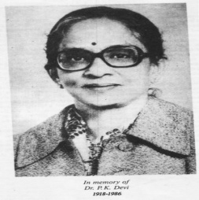 | Prof. P. K. Devi (1918 - 1986)  The Memorial Oration has been instituted by Prof. P. K. Devi Memorial Endowment. Prof. P. K. Devi was instrumental in developing excellent departments of Obstetrics and Gynecology in several medical colleges. She contributed significantly to clinical research in reproductive medicine at national and international level encompassing the Johns Hopkins Institute, PGIMER, ICMR, NIRRCH and WHO.  Her dedication to clinical services in obstetrics and gynecology won her love and respect of young mothers and their families. She knew that clinical research in India is neglected. She had foreseen that if medical teaching and services were to be of good standard, clinical research was essential.  Prof. Devi was also interested in the growth of Ayurveda, the ancient system of medicine, as a science. She participated in several research projects related to Indian medicinal plants and their application to reproductive medicine.
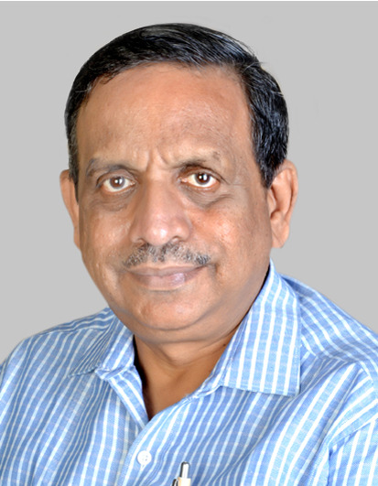 | Prof. (Dr.) Sundararaman  Prof. T. Sundararaman is former executive director of the National Health Systems Resource Centre, New Delhi (2007 to 2014) and then Professor and Dean of the School of Health Systems Studies, Tata Institute of Social Sciences, Mumbai, (2015 to 2019) and more recently served as Global Coordinator for Peoples Health Movement ( 2019-2022).  An MD in internal medicine, for the first 22 years of his professional career he was a faculty of medicine in JIPMER. From 2003, he shifted to working in health systems strengthening and health policy, heading first the State Health Resource Center in Chhattisgarh and then the National Health Systems Resource Centers (2007 to 2014), India’s apex institution for health systems strengthening. He was a Professor and Dean of School of Health Systems Studies in TISS, Mumbai from 2015 to 2019.  His major contributions included design and implementation of India’s National Rural Health Mission including the ASHA programme, the steering committee to draft the National Health Policy 2017, the chairperson of the committee that drew up the blue print for India’s shift to Comprehensive Primary Health Care (Ayushman Bharat, Health and Wellness Centers), and chairperson of the Technical Appraisal Committee of the Health Technology Board, India, the chairperson of CM’s Comprehensive Health Insurance Scheme Review Committee, Tamil Nadu, Co-Chair of the India Government-Civil Society TB Forum. Currently he is an adjunct faculty in the JIPMER International School of Public Health and engages in consultancies with WHO.  Throughout his professional career he has worked voluntarily with people’s health movements for furthering health rights in India. He has published extensively and has exemplary contribution to the advancement in the field of public health.
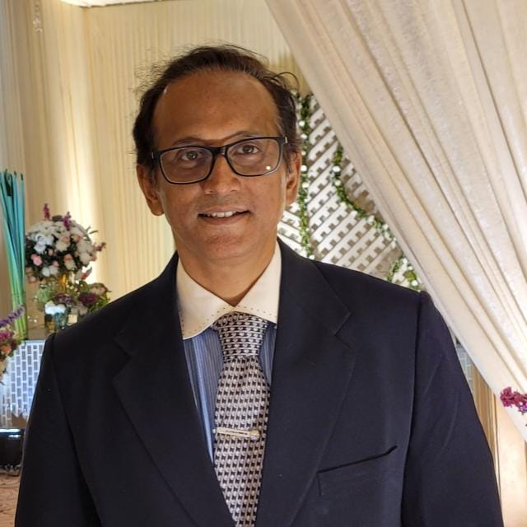  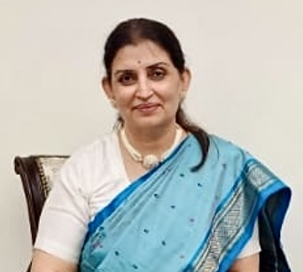 | Smt. Sujata Saunik (IAS)  Sujata Saunik is a senior civil servant from the 1987 batch of the Indian Administrative Service (IAS), Maharashtra cadre, with 38 years of service in public administration. She has led key departments in Maharashtra including Public Health, Finance, Skill Development, General Administration (Services and AIEGG) and Home. She also served as the 48th Chief Secretary of Maharashtra, becoming the first woman to hold this position since the state’s formation 65 years ago. In the Government of India, she worked in the Ministry of Women in Child and Disaster Management wing of Home Affairs as Director. Internationally, she served with the United Nations in Cambodia and Kosovo as Civil Affairs Officer in governance and humanitarian missions. Her academic and research interests focus on the intersections of climate change, public health, and governance. She is Takemi Fellow (2018) at the Harvard T.H. Chan School of Public Health. She also conceptualized SANGAM (Summit of Academia Networking with Government, Allied Health Workers & Medical Professionals), a platform that bridges research and practice in health systems through partnerships with IIT Bombay and the Maharashtra University of Health Sciences. As a seasoned administrator her experience spans from governance, global engagement and academic research to contribute to inclusive and sustainable development.  Dr. Soumik Kalita  Dr. Soumik Kalita is currently Chief Executive Officer and Founder Fam Phy: The Physician on call. He led the creation of the concept of bringing back the concept of the family doctor by building a network of home visiting qualified doctors, who are trained in evidence-based medicine (EBM) especially in the urban context, to address a wide demand-supply gap in primary healthcare service.  He is Adjunct Professor at Trans-disciplinary Family Practice and Research at KIHS MRF Mumbai, Professor of Practice (Specialized Faculty), SVT College of Home Sciences (Autonomous), SNDT University, Juhu Mumbai and Faculty, Family Medicine program, Christian Medical College, Vellore  Earlier he served as Vice President & Head, R & D, Technical Services and Service Delivery, VLCC Healthcare Ltd and also served as Director, Medical Affairs: GSK Nutrition. He has held several academic and research positions at both national and international institutes. He also has served as Medical Officer at primary public health care settings in India gaining vast experience of grass root level health problems and system level challenges.
Prof. P.K. Devi Orations from 1992 – 2024

1992 Prof Sune Bergström, Nobel Laureate, Karolinska Institute, Sweden: “Safe Motherhood in Developing Nations”
1993 Prof. Shanti Ghosh, Consultant WHO: “Whither Health Care for Women & Children!”
1994 Prof. C. Gopalan, Ex. D.G. ICMR, Ex Director, National Institute of Nutrition and Consultant WHO: “Maternal Nutrition - New Insights and Challenges”
1995 Prof. K. Bhaskar Rao, Eminent Gynaecologist/Obstetrician, Madras. Consultant WHO: “Reproductive Health in India by 2001”
1996 Smt. Ela R. Bhatt, General Secretary, SEWA, Winner of Alternate Nobel Prize: “Women's Health Security – Strengthening World of Work”
1997 Prof. J.S. Bajaj, Eminent Diabetologist: “Fetal Growth and Adult Disease: The Cellular & Molecular Mechanisms”
1998 Dr. R.A. Mashelkar, FRS, Director General CSIR: “The Global Potential of Indian Medicinal Plants – An Intellectual and Innovative Challenge”
1999 Dr. Sushila Nayar, Former Union Minister for health, GOI & eminent social worker: “Sevagram Rural Special Program - A Model in Social Obstetrics”
2000 Dr. Ranjit Roy Chaudhury, Ex-Dean, PGI Chandigarh & Member Planning Commission of India: “Ethics in Medical Practice & Research”
2001 Dr. K. Sankari, Eminent Gynaecologist & HOD Gynaecology/Obstetrics, Dr. B. Nanavati Hospital: “Childbearing Beyond Forty Years”
2002 Prof. Naranjan S. Dhalla, Director, Institute of Cardiovascular Sciences, University of Manitoba, Canada: “Role of Oxidative Stress in Cardiac injury due to Ischemia-reperfusion”
2003 Dr. V. Prakash, Director, CFTRI, Mysore: “The Journey of Nutrition through Food – The Road to Well Being”
2004 Prof N.N. Wig, Ex-HOD, Dept of Psychiatry, PGI, Chandigarh: “Motherhood and Mental Health – Indian Viewpoint”
2005 Prof. M.S. Valiathan, Distinguished Cardiothoracic Surgeon, Chairperson, Health CareTechnology Vision 2020: “Sparks from Charak's Anvil”
2006 Dr N.K. Ganguly, Eminent Microbiologist, and Director General of ICMR, New Delhi: “Challenges that India will face in MCH by 2020”
2007 Dr. Vasantha Muthuswamy, Senior Deputy Director General, ICMR: “Recent Advances in the Field of Pharmacology and Traditional Medicine”.
2008 Dr. (Mrs.) Nilima Kshirsagar, Ex Dean GSMC and KEM Hospital Mumbai: “Clinical Pharmacology Sans Frontiers of Gender, Disciplines and Continents”
2009 Dr. (Mrs.) Urvashi Jha, Director of Obst/Gyn & Surgical Oncology, Max Health Centre, Delhi: “Journey from Laparoscopy to Vaginal Surgery”
2010 Dr. Rajendra Badwe, the Director of Tata Memorial Centre, Mumbai and Prof. & Head, Dept. of Surgical Oncology. “Current Advances in Prevention & Management of Breast Cancer”
2011 Dr. Bhushan Patwardhan, Vice Chancellor, Symbiosis International University, “Renaissance in Ayurveda-A Global Phenomenon”
2012 Prof RH Singh Ayurved, expert and teacher: ‘Integrative Health Care- Past, Present & Future’
2013 Prof. Dr. Akhil B. Vaidya, Director, Center for Molecular Parasitology, Drexel University,” Challenges and Opportunities for Malaria Management, Control and (dare we say Eradication?)".
2014 Dr. K. Satyanarayana, Scientist G and Co-ordinator of Department of Health Research, GOI,
“Biomedical Communication Skills and Their Translational Impact on Health”.
2015 Dr. S. Daftary, Former Dean and Medical Advisor, Wadia Maternity Hospital, Mumbai, Medical Education –Journey through Academia and Contributions towards Women’s Health Care
2016 Dr Arvind Chopra, renowned Rheumatologist and Director, CDR, Pune, " Conversion of a Clinician into a Community Physician Scientist- An order in madness”.
2017 Dr. Laxmi Mehta, Professor, Director, Clinical Genetics, Icahn School of Medicine, Mount Sinai New York in USA, “Diagnosis and Screening for Genetic Disorders in the Fetus and Neonate”
2018 Dr. Vijay Raghavan, Principal Scientific Advisor to Govt. of India, “Genomics and human health:
what could an Indian initiative look like?”
2019 Dr. Abhay Bang, Physician and Public Health Expert, SEARCH, Gadchiroli, Maharashtra, India “Research with the People”
2020 Dr. Balram Bhargav- Pending
2021 Dr. Rajesh Kotecha Padma Shri Secretary, Ministry of AYUSH, Government of India "Importance of AYUSH: Principles, Product and Practices for Attaining WHO SDG-II and Addressing the Challenges of Malnutrition”
2022 Dr. Neerja Bhatla, Professor Head, Dept. of OBGYN, AIIMS New Delhi, "HPV Vaccination for Cervical Cancer Elimination Current Status & Scope of Implementation”
2023 Prof. (Dr.) Gagandeep Kang, Director-Enterics, Diagnostics, Genomics and Epidemiology, Global Health, Bill and Melinda Gates Foundation
2024 Prof. (Dr.) Vidita Vaidya, Senior Professor and Co-Chairperson, Department of Biological Sciences, Tata Institute of Fundamental Research " Imprints of Early Adversity: How the brain and body keep Score”

